STATEWIDE INDEPENDENT LIVING COUNCIL

PROGRAMMATIC AND FISCAL POLICIES AND PROCEDURES

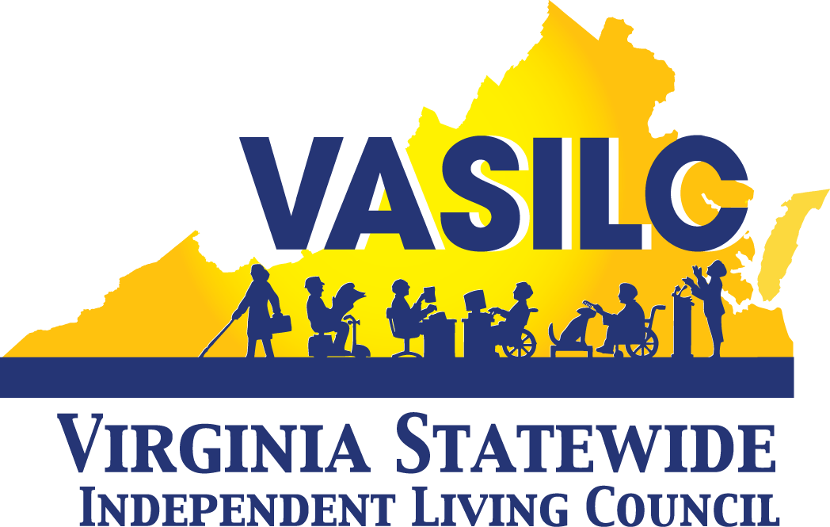
8004 Franklin Farms Drive
Henrico, Virginia 23229

Approved by Full Council, July 2016

TABLE OF CONTENTS
- Purpose 4
- Introduction 4
- Mission Statement 4
- Authority of Statewide Independent Living Council (SILC) 4
- State Plan for Independent Living (SPIL) 5
- Network of the Centers for independent living (CILs) 5
- Membership 6
- Appointment by Governor 6
- Reappointments 6
- Oath of Office 6
- Financial Disclosure And COnflict of interest (COIA) Training 6
- New Member Orientation 7
- Attendance 7
- Training Opportunities 7
- Responsibilities 8
- SILC Representatives to Other Boards and Councils 8
- Meetings 8
- Council Structure 9
- State Plan for Independent Living 9
- Cycle 9
- Development 9
- Opportunity for Public Comment 9
- Oversight and Monitoring 9
- Role of designated state Entity (dse) 9
- Part B Funding 10
- SPIL Budget and Financial Statement 10
- Program Evaluation 10
- Administration for community living 10
- Public Relations and Marketing 10
- Website Maintenance 10
- Correspondences 11
- Spokesperson for Council and Individual Advocacy 11

- Staff 11
- Administrator 11
- Administrative Support 11
- Fiscal Policies and Procedures 11
- Fiscal Reporting Requirements 11
- Records Retention 12
- Travel Regulations 12
- Cancelling Reservations 12
- Disallowed Expenses 12
- Revision of the Manual 13
- Appendices 14

- I. Purpose
The Statewide Independent Living Council (SILC) has developed and enacted the following policies and procedures by virtue of the bylaws of the Council (Appendix I).
These policies and general operating guidelines were enacted and are being adopted for the effective operation of the SILC. The day-to-day functional implementation of these policies and procedures is the responsibility of the SILC Administrator.
Organizational policies and procedures may be amended through the SILC on recommendation of the Executive Committee. The policies and procedures are reviewed annually by the Executive Committee to determine if any changes are necessary.
II. Introduction
- Mission Statement
The mission statement of the Statewide Independent Living Council is, “The Virginia Statewide Independent Living Council will promote policies, programs and activities to maximize independence of people with disabilities by:
- developing, monitoring, reviewing and evaluating the State Plan for Independent Living (SPIL),
- supporting and expanding the state network of Centers for Independent Living,
- creating a culture for full integration and independence,
- advocating systems change for full access and equality in community life,
- educating policy makers and stakeholders about the importance of independent living,
- developing a strategy for collaboration among stakeholders in the disability community,
- leading to full inclusion and independence in the Commonwealth.”

- The Importance and Authority of Statewide Independent Living Council
The SILC is an independent planning body working with the Department for Aging and Rehabilitative Services (DARS) and the Centers for Independent Living (CILs) to increase the impact of independent living services in Virginia. The SILC is composed of gubernatorial appointees who represent people with significant disabilities from across the state, as well as, the interests of other independent living programs and services. The SILC receives its authority from the Workforce Innovation and Opportunity Act of 2014 (WIOA). More information about research, training and technical assistance regarding independent living and statewide councils for independent living is located on the Independent Research Utilization website: www.ilru.org.
The SILC’s composition is set forth in Subtitle H, Section 705 of the Workforce Innovation and Opportunity Act of 2014 (Appendix II).
Members are chosen by the Governor of Virginia, after receiving recommendations from organizations representing a broad range of individuals with disabilities, to serve three year terms, up to two consecutively. The Council must consist of one CIL director, chosen by the other CIL directors, and ex officio (nonvoting) members to represent the DSE and other state agencies serving individuals with disabilities. The majority of voting members must be individuals with disabilities, not employed by a CIL or state agency.

Members provide statewide representation to the Council, represent a broad range of individuals with disabilities from diverse backgrounds, and are knowledgeable about the CILs and independent living services.

- State Plan for Independent Living (SPIL)
The State qualifies for federal independent living (IL) funds because of the existence of the SILC and the SILC's federal mandate to develop a three-year State Plan for Independent Living (SPIL) which outlines IL priorities and identifies IL needs for the Commonwealth's citizens. The SPIL is conjointly developed by the Statewide Independent Living Council and the Directors of the Centers for Independent Living. The SILC must receive public input from individuals with disabilities and other stakeholders about the proposed SPIL. The SPIL is signed by the Chairperson of the SILC, the director of the Designated State entity, and a majority of the directors of the Centers for Independent Living. The Chairperson will designate a subcommittee to develop the SPIL and coordinate the necessary activities.
The current SPIL can be found in Appendix III.
- Network of the CILs
The CILs are non-residential places of action and coalition, where persons with disabilities learn empowerment and develop the skills necessary to make lifestyle choices. Centers provide services and advocacy to promote the leadership, independence and productivity of people with disabilities. Centers work with individuals, local communities, government agencies and the SILC to remove barriers to independence and to ensure equality of persons with disabilities.
For a current listing of the Virginia CILs, refer to Appendix IV.
III. Membership and Member Responsibilities
- Appointment by Governor
Because members are appointed by the Governor, all individual interested in serving on the Council must apply for appointment through the Secretary of the Commonwealth website. Resumes are required with the application.
The SILC has the responsibility to inform the Secretary of the Commonwealth about federal mandates regarding the composition of the Council.
- Reappointments; nomination form
Existing members who desire reappointment must inform the Director of Gubernatorial Appointments in the Secretary of the Commonwealth’s Office in a timely manner and follow those directions.
- Oath of Office
Before a newly appointed member can enter into official duties, he/she is required by Section 49-1 of the Code of Virginia to be sworn in by a judge, clerk, deputy clerk of a court of record, a judge of a district court, the Secretary of the Commonwealth, or a State Corporation Commissioner. The original form must be submitted to the Office of the Secretary of the Commonwealth (Appendix V).
- Conflict of Interest - Financial disclosure and orientation course
The Virginia Comprehensive Conflict of Interest Act prohibits Council members who have a personal interest in a transaction before the Council from participating in the transaction. For the purposes of the Act, a “personal interest” means a financial benefit accruing to the member or someone in his/her immediate family. Knowingly violating the Act is a criminal offense:
Any person who does not file or who knowingly files the Statement of Economic Interests form inaccurately will be charged with a Class 1 Misdemeanor which is punishable by no more than 12 months in jail and a fine of no more than $2,500. A local official who knowingly files the form inaccurately will be charged with a Class 3 misdemeanor which is punishable by a fine of no more than $500. Any person who knowingly files the form inaccurately may also be dismissed from office or employment.
Voting members of the SILC are required by state law to disclose their financial interests before assuming office and then annually on or before December 15. Information pertaining to real estate, business interests, gifts, travel, liabilities, directorships and other matters is subject to disclosure. These disclosure statements are available for review by the public for a period of no less than five years. As state government employees, ex officio members are also required to follow the rules and regulations governing conflict of interest. If designated by the Governor or General Assembly, ex officio members must disclose financial interests by filing a Statement of Economic Interest form annually on or before December 15. Ex officio members should check with their agency’s COIA liaison officer about this requirement. Both voting and ex officio members are further required to complete an orientation course wherein they are instructed in regards to conflict of interests. The course must be completed within 60 days of assuming office or employment and once every two years thereafter.
Refer to Appendix VI in order to link the following websites and PowerPoint presentations: State Conflict of Interest website, State and Local Government Conflict of Interests Act, and the Ethics in Contracting portion of the Virginia Public Procurement Act.
E. New Member Orientation
New members are required to participate in an orientation session prior to voting at the first meeting, per SILC Bylaws. The orientation is arranged by the Administrator and sufficient advance notice is provided to the new members.
F. Attendance
Member attendance at quarterly SILC meetings and other activities (as assigned) is mandatory. The Secretary of the Commonwealth tracks attendance at meetings on a yearly basis. The Administrator submits the Board Profile to the Secretary’s office each year by the specified deadline. The Executive Committee of the SILC is charged with monitoring attendance and notifying the Secretary’s Office under certain conditions, per SILC Bylaws. Members who cannot attend meetings must submit an absence form to the Administrator prior to the meeting or within 3 days following a meeting in case of an unexpected absence (Appendix VII).
Ex officio members are permitted to send designees to SILC meetings, as appropriate and necessary.
G. Training Opportunities
Members are encouraged to develop the skills needed to be an effective Council member and to obtain proficiency in independent living philosophy, history and concept of service provision. Training sessions are offered on a frequent basis through Independent Living Research Utilization (IL-Net), the National Council on Independent Living (NCIL) and the Association of Programs for Rural Independent Living (APRIL) in the form of on-line courses and webinars. Members are encouraged to attend annual conferences such as the NCIL and APRIL Conferences, and the SILC Congress, based on the available funds in the budget and the priority order set forth by the Council.
H. Responsibilities
It is each member’s responsibility to:
- Reply by specified deadlines;
- Inform the Administrator about any changes in personal information for the roster;
- Prepare thoroughly for meetings in order to make informed decisions;
- Allow for sufficient time to fulfill SILC duties;
- Arrange for transportation to/from meetings in a timely manner;
- Honor all cancelation policies (for example, lodging).
- Responsibilities, values and qualifications are explained further in the SILC Job Descriptions (Appendix VIII).

I. SILC Representatives to other Boards and Councils
The Chairperson has the responsibility of designating SILC representatives to other Boards and Councils, including, but not limited to:
- The State Rehabilitation Council of the Department for Aging and Rehabilitative Services;
- The State Rehabilitation Council of the Department for the Blind and Vision Impaired; and
- The Community Integration Implementation Team.

IV. Meetings
- Meetings are scheduled by the Council at the fourth quarterly meeting based on the calendar year and advanced forward. Adequate meeting notice is provided to all members. The meetings are held quarterly and are open to the public. The meetings must adhere to the requirements of Freedom of Information Act (FOIA). Closed meetings can be called in special circumstances allowed by FOIA. Minutes are taken at every meeting and are posted to the SILC website. Further information regarding FOIA can be found in Appendix IX.
In order to ensure equal access and participation in all Virginia SILC activities, auxiliary aids, alternate formats, and services are made available to individuals with disabilities upon a timely request (Appendix X). All meeting notices include accessibility statements.
SILC meetings are governed by parliamentary procedure as defined in Robert’s Rules of Order Newly Revised.
V. Council Structure
- The Chairperson may form committees, subcommittees, work groups and ad hoc committees as needed to carry-out the duties of the Council. The Chairperson determines which committees oversee the main goals as specified on the SPIL. Standing committees are the SPIL Goals/Operations Committee to oversee the SPIL timelines, and the Executive Committee. The Chairperson appoints a Nominating Committee to develop a slate of officers by the second meeting based on the calendar year. All committees and work groups adhere to the requirements of FOIA.
VI. State Plan for Independent Living (SPIL)
- Cycle
The SPIL covers a three-year span. The current SPIL is located in Appendix III.
- Development
The SILC has in place timelines of activities that are used to implement the current SPIL and to develop the next SPIL. The timelines are monitored by the SPIL Goals/Operations Committee (Appendix XI).
- Opportunity for Public Comment
A draft of each SPIL is available for public review and open for comments, in compliance with federal regulations and guidelines. The SPIL Development Subcommittee sets forth a sufficient time period for public commenting and specifies the means of distributing the SPIL draft to stakeholders.
- Oversight and monitoring
The SPIL Goals/Operations Committee oversees the SPIL Implementation Timeline to ensure that deadlines are met and that the activities are outcomes-focused.
- Role of DSE
The SPIL specifies the designated state entity (DSE), which serves as a fiscal agent for the SILC. The DSE carries the following authority: receiving, accounting, and disbursing of funds received by the State based on the SPIL. The DSE provides administrative support services for Part B programs and is responsible for record keeping and allowing access to such records, as requested.
- SPIL budget and financial statement
DARS functions as the fiscal agent of the federal Part B funding and maintains accounting records for the Council. DARS provides the data needed for the Administrator to develop quarterly financial statements and budget worksheets. These reports are submitted to the Council for review and adoption at the quarterly meetings.
- Program evaluation
SILC is evaluated yearly using a variety of approaches including the SPIL timelines, work plans, stakeholder feedback, and the federal 704, Part I – Yearly Reporting Instrument. Outcomes and measures are specified and the SILC is responsible for monitoring and evaluating SPIL results. Each SILC committee is responsible for reporting to the SILC Administrator on the objectives achieved and/or the barriers encountered to fulfilling the objectives within the quarter. This information assists the SILC Administrator in preparing the annual 704 Report.
VII. Administration for Community Living (ACL)
The SILC, along with the DSE, submits all reports to the ACL, provides information and answers inquiries, as required and requested, by the specified deadlines.
ACL on-site monitoring visits are conducted periodically and according to a schedule set forth by that agency. The SILC component of the ACL on-site visits is to monitor compliance with the assurances contained in the SPIL. SILC members may be called upon to participate in meetings with ACL representatives as needed, and should make every effort to participate. Sufficient advance notice of on-site visits and agenda of scheduled meetings are provided.
VIII. Public Relations/Marketing
- Website maintenance
The SILC Administrator is responsible for updating the SILC website with the assistance of the DARS Webmaster. The Council has the authority to make changes to the website and/or the information contained therein at any time. Ongoing updates to the SILC history portion of the website is reviewed and updated bi-annually. Posted information remains on the website for a time period deemed reasonable by the SILC. The website address is www.vasilc.org.
- Correspondences
The Administrator drafts correspondence according to SILC directives and finalizes the documents for the Chair’s signature. All letters are open to public review. Any or all correspondence is retained as specified by state records retention guidelines and FOIA.
- Spokesperson for Council and individual advocacy
The Chairperson of the SILC has the authority to act or to execute any activity on behalf of the entire SILC body, if such authority is granted to him/her by state laws, the SILC’s bylaws, or by specific resolution of the SILC, including speaking publicly on behalf of the Council. No other member may speak on behalf of the Council. All members are permitted to make comments as individuals about topics of their choice.
IX. Staff
- Administrator
The Executive Committee evaluates the performance of the Administrator and completes the evaluation form by the deadline set forth within the performance review cycle. The form is sent to the Administrator’s supervisor as an addendum to the overall performance evaluation. The Employee Work Profile (e.g., job description) is reviewed and updated yearly by the Administrator. The Administrator’s immediate supervisor signs the profile and submits it to the Human Resources Unit of DARS. The most current profile can be found in Appendix XII.
- Administrative support
The Administrator supervises one hourly wage position (Program Support Technician, Senior). The Administrator updates the Employee Work Profile of the wage position, and provides ongoing guidance and yearly evaluation.
Personnel records of all SILC staff members are maintained by the Human Resources Services Unit of DARS.
X. Fiscal Policies and Procedures
- Fiscal Reporting Requirements, Accounting System and Audit
The Department for Aging and Rehabilitative Services, as the DSE, provides oversight for the SILC budget:
- Grant awarding and management related to the SPIL goals
- Processing of payments for the SILC
- Technical assistance to the SILC
- Periodic financial auditing of the SILC

- Records Retention
Records that are required for DARS departmental and federal and state regulatory and evaluation purposes shall be made available and maintained according to the provisions of FOIA.
- Travel Regulations

Council members are reimbursed for reasonable and necessary costs of travel, meal and lodging expenses, provided the trip is pre-approved by the Council. All requests for reimbursement must comply with State Fiscal Guidelines. Out of state travel requests require further approvals from the Commissioner of the DSE and the Secretary of Health and Human Resources, as appropriate. To be reimbursed for travel, members must complete the necessary forms provided by the Administrator to receive reimbursement (Appendix XIII). Reimbursements are calculated using the State’s current Meals and Incidental Expenses Rate Table.

- Cancelations of trip reservations
Members must provide a two- week notice of cancelations or changes to trip reservations. The member will be responsible for any incurred charges due to late notices, except in the event of unforeseen emergencies.
- Disallowed Expenses

- Lost or stolen articles
- Alcoholic beverages
- Damage to personal vehicles, clothing or other items
- Services to gain entry to a locked vehicle
- Movies charged to hotel bills
- All expenses related to the personal negligence of the traveler, such as fines
- Entertainment expenses
- Towing charges
- Expenses for children, spouses and companions while on travel status

The above list is not all-inclusive. Travelers should use prudent judgment and remember that all travel expense accounts are open to the public and must be able to sustain the test of public review.

XI. Revision of the Manual
The Administrator oversees the manual and alerts the Executive Committee when updates are needed. The Executive Committee reviews the manual at least annually, and refers any revisions to the full Council for a final decision. The Policy and Procedures Manual is officially updated by the Council by simple majority.
Appendices (I – XIV)

POLICY MANUAL
TABLE OF APPENDIXES

APPENDIX I BYLAWS
APPENDIX II SUBTITLE H OF WIOA
APPENDIX III SPIL
APPENDIX IV VIRGINIA CILs LISTING
APPENDIX V OATH OF OFFICE
APPENDIX VI CONFLICT OF INTEREST/ETHICS
APPENDIX VII MEETING ABSENCE FORM
APPENDIX VIII JOB DESCRIPTIONS FOR OFFICERS
APPENDIX IX FOIA
APPENDIX X MEETING ACCESSIBILITY (STANDING RULES)
APPENDIX XI SPIL TIMELINES
APPENDIX XII SILC ADMINISTRATOR WORK PROFILE
APPENDIX XIII TRAVEL REIMBURSEMENT FORMS
APPENDIX XIV IL ACRONYMS LISTING

